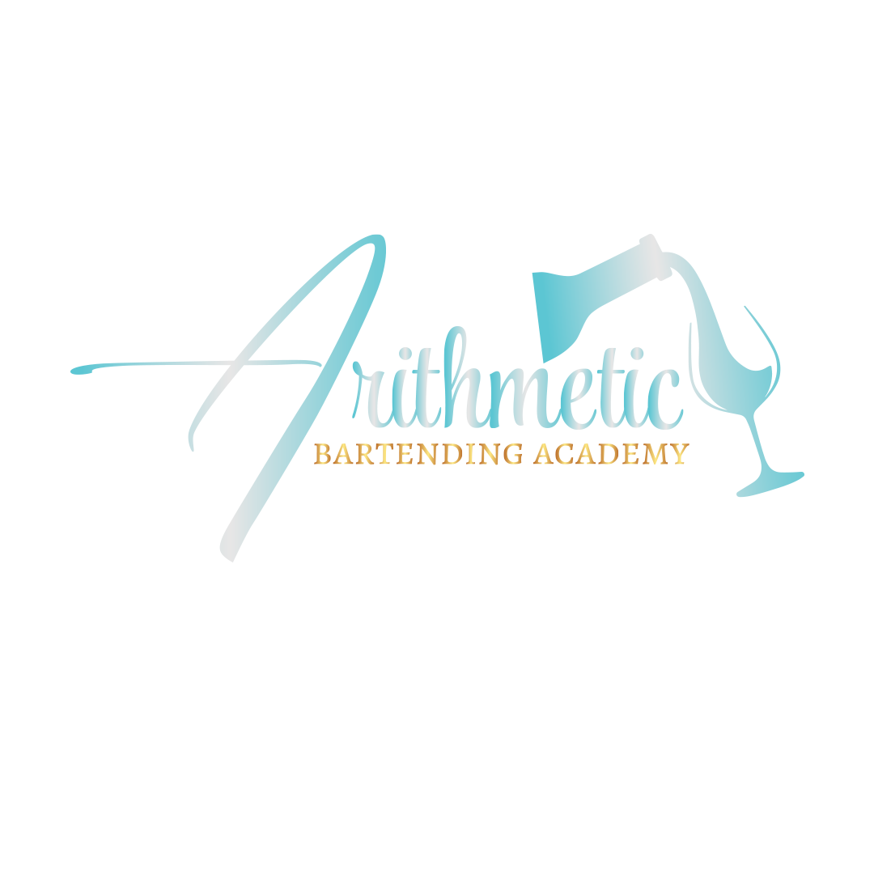

SCHOOL CATALOG
2025

Arithmetic Bartending Academy
23980 Chagrin BLVD #202
Beachwood, Ohio 44122
216-323-7694

Registration Number: #2259

Catalog Publish Date
01/09/2025

TABLE OF CONTENTS

- Introduction Page 4
- Administrative Staff, Faculty, Facilities Page5
- Admission Requirements Page 5
- Class Schedule Page 6
- Process and Grading Page 6
- Enrollment Procedures Page 6
- Graduation Requirements Page 7
- Attendance Page 7
- Dress Code and Conduct page 8
10.Cancellation and Refund Policy page 9
11.Placement Policy page 9
12.Hoilday page 9
13.Program Outline page 10
14.Tuition page 11
15.Student Complaint Procedure page 11

INTRODUCTION

We here at Arithmetic Bartending Academy take pride in our studies of bartending. We focus on what makes bartenders, bartenders. We start at the beginning with customer service and making sure that our students are knowledgeable about safety, laws, and liabilities in the industry of bar. Our instructors train you on how to preform out in the field along with the drink making skills you will need to become a successful bartender.

Our school is small in classroom size, which helps us to know our students and to take time with each student to be sure the student receives the attention required to be able to advance in a rewarding career of bartending. Our instructor still works in the field of bartending and we feel that gives our students a always fresh updated training on what is going on in bartending present day.

Here at Arithmetic Bartending Academy, we specialized in showing our student how to adapt working in EVENTS, RESTAURANTS, DIVE BAR, CONCESSIONS bartending and some much more.

ADMINISTRATIVE STAFF, FACULTY, FACILITES

VALERIE CROSS
OWNER/DIRECTOR/INSTRUCTOR

The school is designed for the training of students for studies of basic bartending and mixology. Our school room is 400 sq. ft and is designed to simulate an actual bar with lounge area.

Arithmetic Bartending Academy is located at 23980 Chagrin Blvd. Suite 202 Beachwood, Ohio 44122. We have plenty of parking in the front and back of our building.

In our classrooms we use actual glassware & plastic cups along with tools needed for our students to train with. Students will be shown the difference with glassware used in restaurants and events vs plastic cups used in events and
concessions.

ADMISSION REQUIREMENT

All applicants must be 18 years and older. A previous knowledge of bartending is not required. All applications for class will be reviewed by the director for approval, no one will be denied admittance base on age, sex, race, or religion. We are an equal opportunity school with a diverse student base.

CLASS SCHEDULE

ONE WEEK COURSE- DAYTIME
(20 Hours Course) Monday-Friday 10:00am to 2:00pm by appointment only.

ONE WEEK COURSE- EVENING
(20 Hours Course) Monday-Friday 6:00pm to 10:00pm.

FIVE WEEK COURSE- DAYTIME
(THIS IS A SATURDAY SESSION 5 WEEKS) 10:00am to 2:00pm by appointment only.
(THIS IS A SUNDAY SESSION 5 WEEKS) 10:00PM to 2:00pm by appointment only.

PROCESS AND GRADING

Students will be graded on daily basis to be sure that the work is being understood and completed. Students must complete a practical exam with a grade of 80% or better. On completion of class Certificate of Completion will be issued to student upon satisfactory fulfillment of all courses.

ENROLLMENT PROCEDURES

Each student before attending class must complete an application form and a student enrollment form. Space is limited all deposits must be paid to book your slot for class. All monies must be paid in for before the 1st day of class.

GRADUTION REQUIREMENTS

Student must attend all class days assigned.
Student must complete all class hours.
Student must receive a passing grade of 80% or better.
If the student misses a class or does not earn a passing grade, the student will be allowed to schedule make up time at no charge to retake or complete a section of the class to earn a passing grade.

ATTENDANCE

Student’s attendance is required to complete the course. Students must give the school notice of any intended absences. Classes that are missed must be rescheduled to complete the course. All reschedule courses will be made by the instructor. If the student is absent 2 times within a course week or weekend session, that will result in dismissal if a valid reason is not given to the school. If the student requests a leave of absence, it will be reviewed by the school instructor or director for approval and will be valid for 1 year to reschedule classes missed. After one year without additional information or rescheduling can result in dismissal.

Students have the right to an appeal by submitting a written appeal letter within 48 hours of being notified of dismissal. Once the appeal has been reviewed, and if the decision has been approved for reinstatement, the student will be able to reschedule class at no additional cost.

DRESS CODE AND CONDUCT

We require our students to be dressed appropriately, neat in appearance with professionalism. All Students and Staff will conduct themselves in an orderly manner. All students are encouraged to always maintain a professional attitude and to conduct themselves accordingly. We reserved the right to dismiss any student who does not conform to our school standards.

CANCELLATION AND REFUND POLICIES
The school provides education and training services to the community. The registration of a student in the assignment of class space, the employment of instructors, and other provisions must be contracted in advance. For these reasons, there will be a no funds except for the what is outlined in the points below.
- Subsequent to the entrance date, all funds paid by the applicant will be refunded if requested within 5 business days after signing the enrollment agreement or the date of the initial deposit. After 5 business day the school will refund all monies paid by the applicant less $100.00 in administrative fee.
- Uniform tuition refund policy: An enrollment agreement or application may be cancelled within five (5) calendar days after the date of signing provided the school is notified of the cancellation in writing. The school staff shall promptly refund in full all tuition and fees paid pursuant in the enrollment agreement. Such refund shall be made no later than thirty days after cancellation.
- Refunds in clock hour programs shall be made for each academic term in accordance with the following procedures:

- A student who starts class and withdraws before the academic terms is fifteen percent completed will be obligated for twenty-five percent of the tuition and refundable fees plus registration fee.
- A Student who starts the class and withdraws after the academic term is fifteen percent completed but before the academic term is twenty-five percent completed will be obligated for fifty percent of the tuition and refundable fee plus registration fee.
- A student who starts class and withdraws after the academic term is twenty five percent complete but before the academic term is twenty-five percent but before the academic term is forty percent completed will be obligated for seventy-five percent of the tuition and refundable fees plus the registration fee.
- A student who starts class and withdraws after the academic term is forty percent completed will not be entitled to a refund of the tuition and fees.

PLACEMENT POLICY

In Compliance with the Federal Trade Commission of Ohio State Law. Arithmetic Bartending Academy does not guarantee the student a job. The students understands that upon graduation, the tuition paid was for instruction, not job placement. Our school have relationships with companies that when hiring we can advise on job placement assistance. Our school during peek months are contacted by companies and we will reach out to students to be considered for interview for employment. Our school is designed to train in the profession of bartending, Our goal upon graduation that our beginner students will be ready for entry level bartending.

HOILDAYS

There will be no classes on following holidays:

NEW YEAR’S EVE NEW YEAR’S DAY
MEMORIAL DAY INDEPENDENCE DAY
LABOR DAY THANKSGIVING DAY
CHRISTMAS EVE CHRISTMAS DAY
Any classes scheduled to start on a holiday will begin the following day. Instruction missed due to a holiday will be made up in a day and time designated by your instructor.

BARTENDING AND MIXOLOGY PROGRAM OUTLINED

- CLASS DISCUSSION (4hours): We have a 30-page class book that we review. We go over what it means to be a bartender/mixologist. From customer service/laws & liabilities and more. Our students will learn the fundamentals of bartending.
- MIXOLOGY AND BARTENDING (8 hours):​Our students will be taught drink recipes and will be given the opportunity during lab time to work behind the bar to practice the recipes, skills to preparing and creating drinks,
- EVERYDAY CUSTOMER PROCEDURES (2 Hours) Our students will learn the proper ways of dealing with their customers. They will learn how to handle problems and how to communicate with their customers.
- BASIC BAR MANAGEMENT (2 hours): Our students will be given a clearly defined comprehensive look for making a profit the success of any operation.
- PREPARING GARNISH/MEASURE POURING (2 hours)​: Our students will learn the preparation of lemon, lime, orange garnishes etc, students will learn the preparation of different juices and mixers. Symbols, abbreviations, and measurements will be encountered.
- YOUR BAR & EQUIPMENT (2 hours):​Our students will be introduced to the bar and the equipment they will be using in the field.

Administrative Fee -- $50.00
Tuition $250.00
Book Fee $50.00
Total Program Cost $350.00

Student Complaint Procedures If a student has any problems, they will be encouraged to speak to the school director to find a reasonable solution. The director will assist in identifying the problem and take action to alleviate the problem. The complainant will receive a written response within five (5) working days. If the problem can’t be resolved, the student has a right and is encouraged to contact the State Board of Career and Colleges 614-466-2752

30 East Broad Street, Suite 2481
Columbus, OH 43215
Phone: (614) 466-2752
Fax: (614) 466-2219
Toll Free (877) 275-4219
E-mail: bpsr@scr.state.oh.us

